

**Name : Malik Huzaifa Arif**

**Class: Bscs7c**

**Roll number:19-Arid-5188**

**Subject:MPL**

**QUESTION 1**

**Nextline()**

The ****nextLine()**** method of the ****Scanner**** class is also used for taking input from the user. In order to use the nextLine() method, we also need to create an instance of the Scanner class. The nextLine() method is capable of reading input till the end of the line. So, it stops reading input from the user when the user presses the enter key or line change.

**Example:  
public** **static** **void** main(String[] args)  
  { Scanner sc = **new** Scanner(System.in);  
 System.out.println(“enter string”)  
  String Input = sc.nextline();  
  System.out.println(“String”+Input);  
**Input:**   
Enter string Great Pakistan  
**Output:**    
Enter string Great Pakistan  
String Great Pakistan

**Next()**

The next() method of the Scanner class is used for getting input from the user. In order to use the ****next()**** method of the Scanner class, an instance of the Scanner class needs to be created. The next() method stops reading input from the user until it receives a white space(" "). So, it returns the next complete token from the Scanner.

**Example:  
public** **static** **void** main(String[] args)  
  { Scanner sc = **new** Scanner(System.in);  
 System.out.println(“enter string”)  
  String Input = sc.next();  
  System.out.println(“String”+Input);  
**Input:**   
Enter string Great Pakistan  
**Output:**    
Enter string Great Pakistan  
String Great

**QUESTION 2**

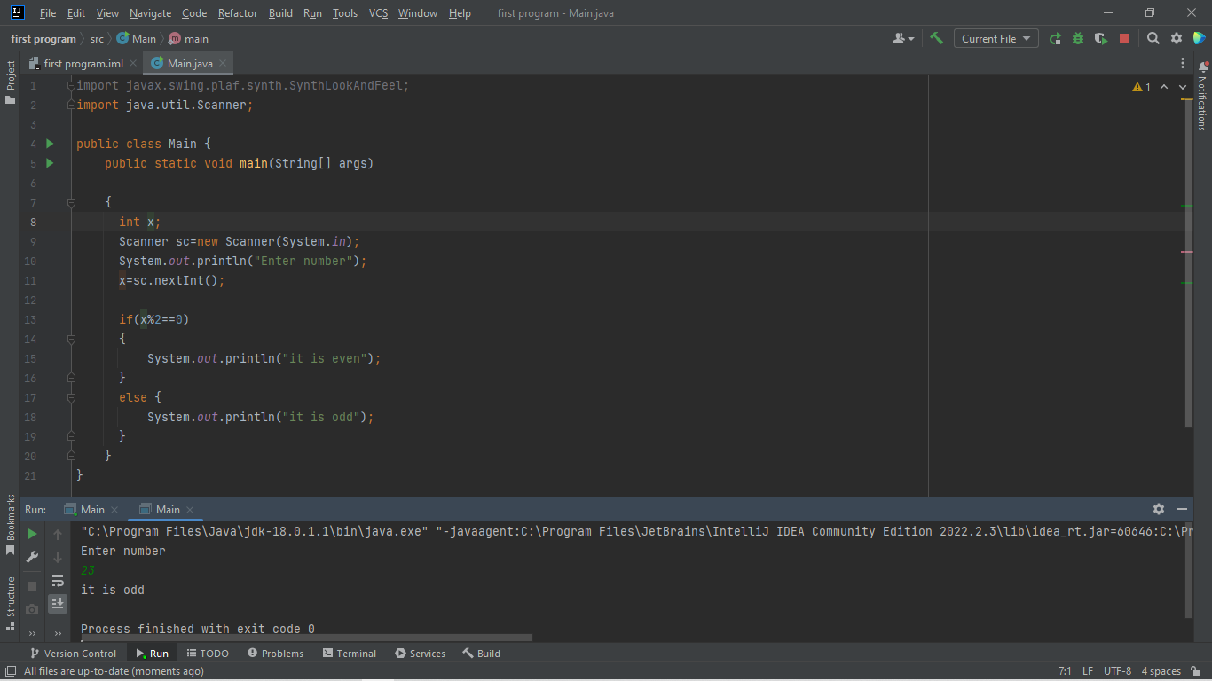

**QUESTION 3**

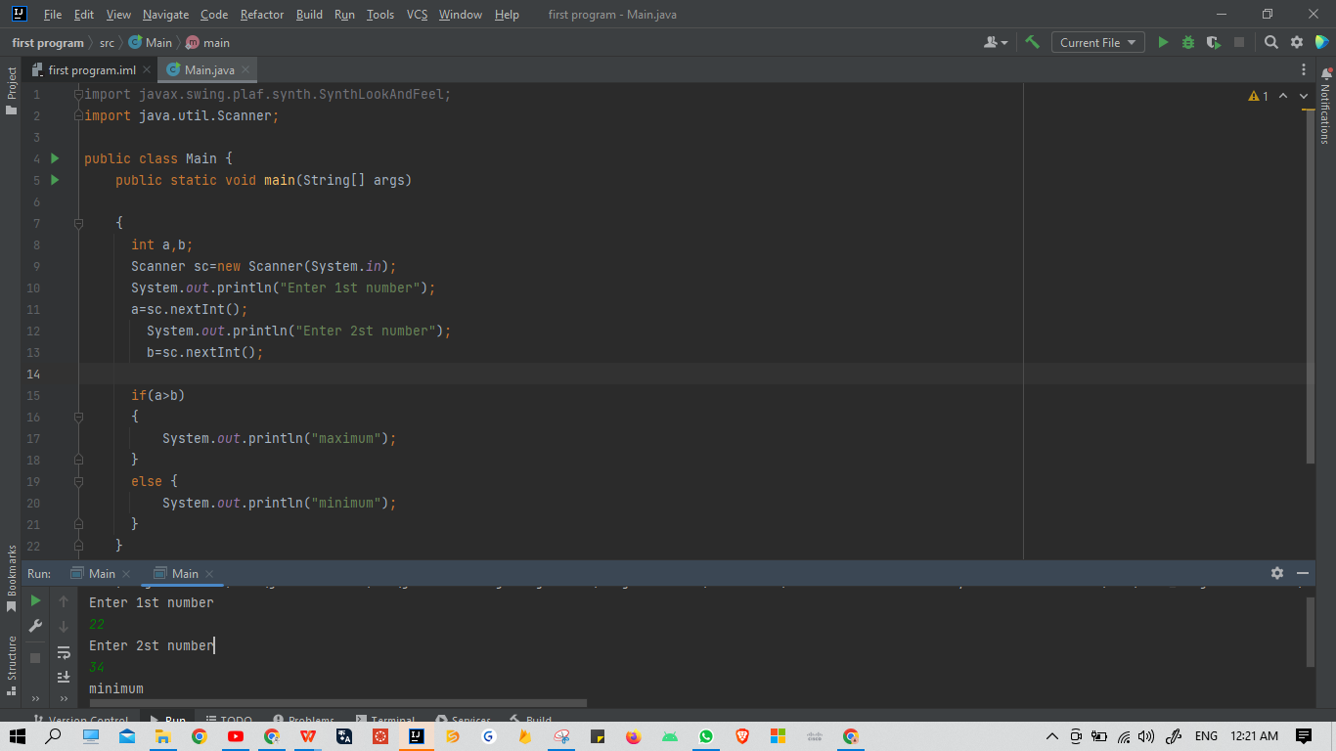

**QUESTION 4**

